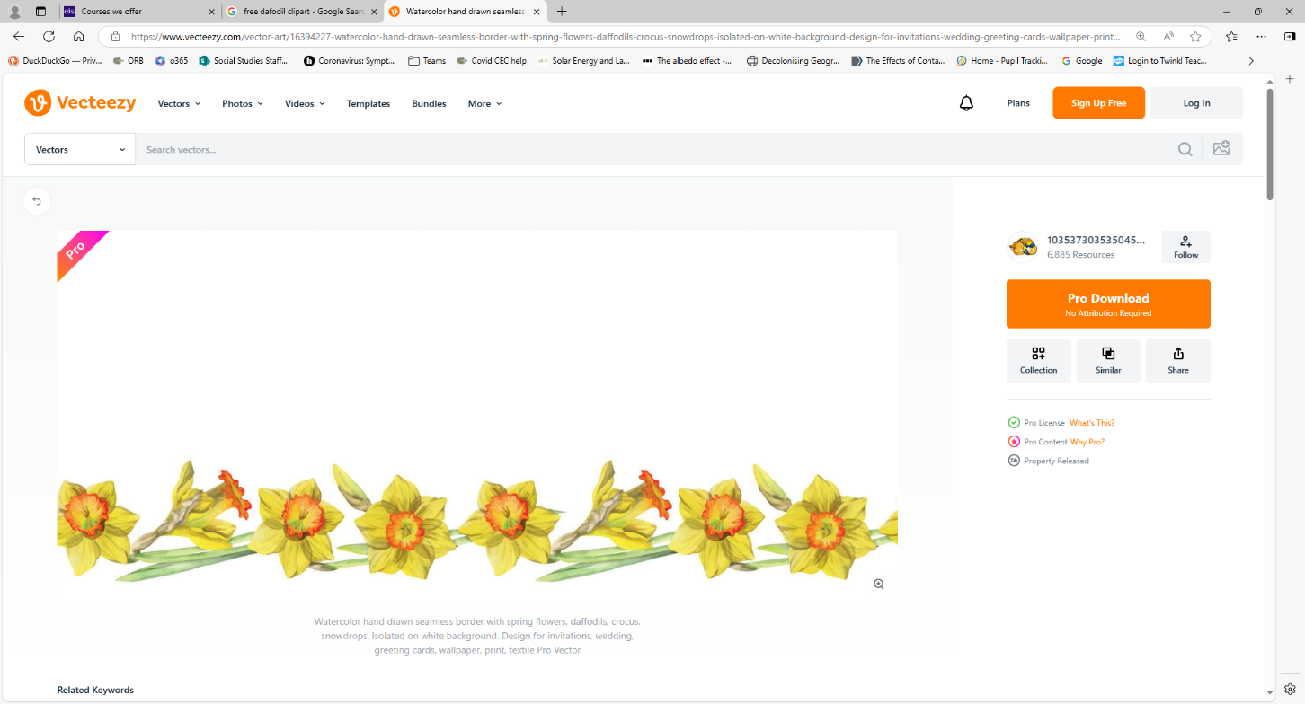
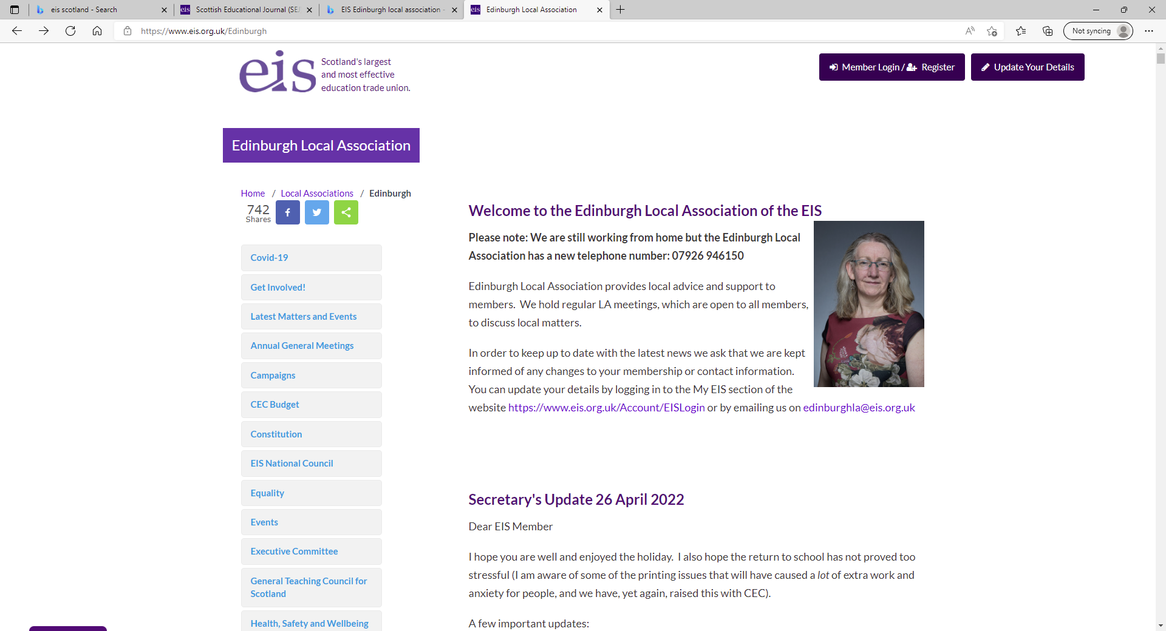
March 2025
Learning Reps News

Looking Forward to PRD / PU (again)
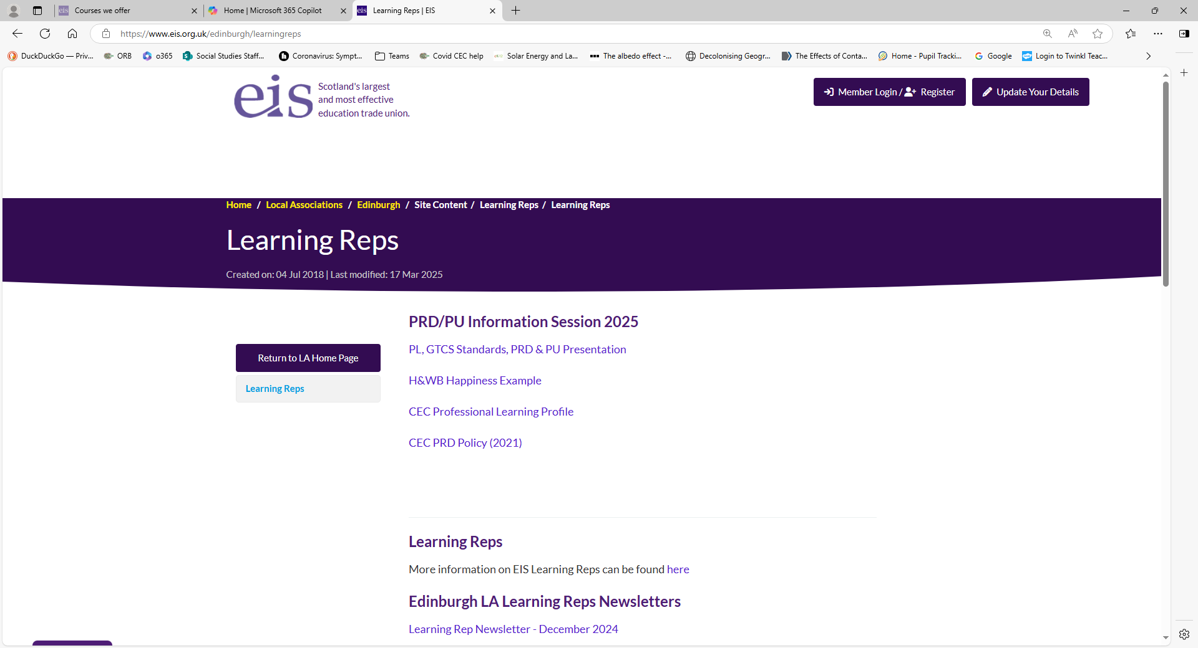
Spring has sprung and we see evidence of renewal and growth all around us (hope you like this link to PRD!). With support from Marni at the Local Association and EIS HQ we recently ran a PRD / PU information session which was organised as a hybrid event for the first time - this meant that many more people were able to participate. In the presentation we were able to refer to key GTCS and CEC Policy and Guidance documents to inform and support members as we approach the ‘PRD meeting season’. For those that were unable to attend and are still a little uncertain about your obligations the materials are available for you to peruse on our Local Association’s Learning Rep page.
see link here: Learning Reps | EIS
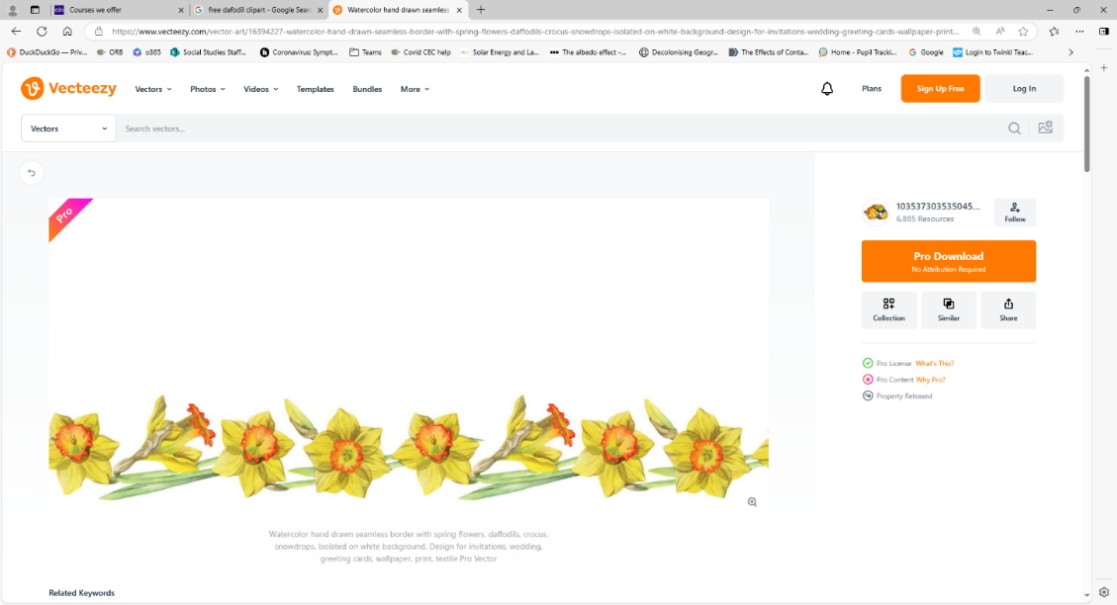
The powerpoint presentation offers a simple and pragmatic approach that utilises CEC’s Professional Learing Profile (PLP). Most people were also interested in the H&WB example which exemplies how to use The Professional Learning Cycle Model and a GTCS self-evaluation wheel to complete your own (PLP). You will also find CEC’s PRD Policy and Guidance Document which is referred to in the presentation.

Health and Wellbeing (of self, colleagues, children & young people in my care)
A call to raise the profile of H&WB through everyday conservations
We continue to encourage and seek ways for members to develop H&WB as an aspect of their own Professional Learning. In our information session we repeated the requirement for all members to ensure that their own Professional Learning is reflected upon against the GTCS Standards. This is a must!
In reviewing the ‘Standard for Career-Long Professional Learning’ it is unmistakeable that H&WB is integral to the GTCS’s idea of what it means to be a teacher in Scotland:
1.1 Professional Values: Promoting health and wellbeing of self, colleagues and the children and young people in my care.
The GTCS provides a context for this by explaining that: ‘Professional values help to develop our professional identity and underpin a deep commitment to all learners’ cognitive, social and emotional growth and wellbeing. They provide the foundation to support and encourage teachers to see the whole child or young person and their needs. They are integral to, and demonstrated through, all our professional relationships, thinking and actions and all that we do to meet our professional commitment as teachers registered with GTC Scotland’. 65de0f44207e8f4e9782e858_GT3790~1.PDF
To fulfil this bold and confident vision of our modern teaching profession it is clear that we must develop a deep understanding of ourselves as practitioners operating in a complex and dynamic environment. However, as the metaphor rightly suggests ‘you can’t pour from an empty cup’ so without good health and wellbeing of self, little if any of this is possible. Particularly so when as a valued colleague you might not even be present! As recently reported by the BBC (24th March 2025) the number of days teachers in Scotland have been absent because of stress has risen dramatically in the last six years. Shocking as the evidence is, it should come as no surprise to any teacher that in Edinburgh the total number of days missed by teachers due to stress rose from 3,594 in 2017/18 to 8,879 last year. And of course this takes no account of the significant number of teachers who are leaving the profession because of stress which is inextricably linked to workload.
The EIS continues to campaign around these issues for structural change but in the short term it is imperative that collectively we understand the value of H&WB related Professional Learning for ourselves, as well as the young people we seek to support. As such, seeing H&WB as an area for professional development is not only legitimate in terms of reflecting upon GTCS Standards as a basis for enhancing our capacity for professional growth, but entirely necessary for our own personal health and wellbeing, and that of our profession. Please consider this when approaching your own PRD, and please continue to help us raise the profile of H&WB of ‘self’ in your own workplaces through everyday conversations. It is vital that we continue to elevate the importance of this with our managers so many thanks in advance.
Teaching was too stressful so I left to become a lorry driver – BBC News
Calling all Probationer Mentors (past or present)
Along with Allan Crosbie, our EIS President, Martyn is working with CEC on a project to evaluate and improve the experience of Probationer Mentors. As you are aware supporting new colleagues into our profession is crucial but also very demanding. Martyn is keen to have a chat with you about your experiences as a mentor, particularly in relation to any training you have undertaken, or were offered to support you in your role. We would appreciate it if you could contact Martyn on the email below.
Your Learning Reps
Martyn and I are your Learning Reps. In our role as Learning Reps we seek to support and promote the learning aspirations of you the members. We meet regularly to discuss and plan for areas of learning that we would like to focus on over the year, but are there any areas of personal professional interest that you would like to develop? We are always keen to support members and offer advice where we can. Please do not hesitate to get in touch and we will always try to get back to you as soon as possible. Like most of you we are classroom teachers who understand the difficulties and challenges we all face in juggling busy work commitments and our own learning. Hopefully we will get the chance to meet and engage with some of you in the near future. For the moment have a peaceful and restful break.
dshaikh@eis-learnrep.org.uk
mcheung@eis-learnrep.org.uk

