Using situated learning and pro-social approaches to improve gender equality in engineering education

Introduction
Prior to lecturing I was an engineer, and, with the United Kingdom (UK) having only 16.5% female engineers (EngineeringUK 2022), I often worked in all-male teams. Luckily, I was never a victim of explicit discrimination, but I did encounter unconscious bias: equipment stored on shelves beyond reach, “man” portable instruments too heavy for me, and adjustments requiring long arms. My research suggests that this is prevalent, particularly in product design (Criado-Perez 2019). Many products, for example virtual-reality headsets and personal protective equipment, would be more serviceable if engineered by more diverse teams, but with few women studying engineering (EngineeringUK 2020), this is a self-perpetuating problem. I reflected on novel ways to change this (Gray 2021) which included delivering situated learning with a focus on industry-relevant projects with pro-social bias (Gray 2022). My hypothesis is that, by getting students to collaboratively work on projects which emphasise design for diversity, and credit tacit and creative skills, awareness of gender inequality is raised, thus making engineering subjects more attractive for women to study.

In my current role with UHI North Highland, I supervise Higher Education (HE) students’ projects at Scottish Credit and Qualifications Framework (SCQF) levels 8 to 10. Students’ projects give us excellent opportunities to develop graduate attributes (UHI 2021) as they require critical thinking to solve real-world problems and challenges in novel and unique ways (Larson et al. 2020). Project based learning enhances students’ abilities to apply theory, whilst also explicitly developing their practical and research skills (Shekar 2012); perhaps more importantly, it also enhances their tacit professional skills. In particular, interdisciplinary group projects develop interpersonal skills, reflective practice, social awareness, and the ability to value and work with a broad range of people and situations (Van den Beemt et al. 2020).

Background: The Policy, Context, and Review of the Literature
Catering for equality, diversity, and inclusion (EDI), in all education, is vitally important since students who encounter discrimination, stereotyping, or prejudice on their course, commonly manifest poor educational attainment, physical, and emotional wellbeing (Cornell and Kessi 2021). In industry, a dearth of diversity negatively impacts products and performance. For example, McKinsey & Company found that companies with more than 30 percent women executives were more likely to outperform companies where this percentage ranged from 10 to 30 (2020). Additionally, despite women driving 70 - 80% of all purchases (Davis 2019), males still dominate engineering design teams, resulting, for example, in protective equipment which doesn’t fit or protect females, and medical or gaming devices which are too big for women (Criado-Perez 2019). Although EngineeringUK reports an increase of woman working in UK engineering roles, from 562,000 in 2010 to 936,000 in 2021 (2021:2), university engineering courses still suffer from a lack of diversity. Retention of women in engineering education remains a problem (Royal Academy of Engineering 2020: 6); the reasons for this are varied from ‘laddism’ in the environment (Stentiford 2018) and insufficient support (Casad et al. 2020), to few empathetic mentors and consequential imposter syndrome (Kricorian et al. 2020).

Recently, the Engineering Council has placed increased emphasis on the promotion of EDI, and of ethics, in accredited programs (Engineering Council 2020: 7, 11). We plan to accredit UHI’s Bachelor of Engineering with Honours (BEngH), so this is now a significant course design factor. Professional Standards for Lecturers in Scotland’s Colleges also require the promotion of inclusion, and development of partnership working (General Teaching Council for Scotland 2020: 5-6). We are required to meet these standards as registered lecturers, and as employees, with one of UHI’s key strategic values being to celebrate diversity through learning and teaching (2023: 6). Although many European Higher Education Institutions have policies and strategies to address EDI, in engineering education these tend to be rather narrow and focused on diversity of recruitment (Direito et al. 2020). Often, education’s celebration of diversity lacks substantive discussion (Vu Tran 2017). The importance of equality, and in particular gender equality, in engineering, is something I have strived to impart for many years – as a role model and mentor, a member of women’s engineering societies, through student induction, and within my course materials and teaching. I was awarded a National Teaching Fellowship in 2021 (AdvanceHE) for my efforts to maximise my programme’s inclusiveness.

Wajngurt and Sloan (2019) have demonstrated that the incorporation of creative arts in Science, Technology, and Mathematics (STEM) courses, positively engages female students; this suggests that a more interdisciplinary approach could reduce the bias. A good example of this in practice is the Arduino microprocessor which was designed to combine technology and art to allow students, at the Interaction Design Institute Ivrea, to easily animate their interactive designs (Parks 2023); it has gone on to become, perhaps, the world’s most popular hobbyist, educational, and professional micro-computing platform. Women are also found, in general, to be more pro-social than men, underpinned by stronger dopaminergic responses to rewards for generosity, altruism, and inequality aversion (Soutschek et al. 2017). Bielefeldt and Canney (2015) showed that women engineering students indicated higher social responsibility than men. Thus, curriculum which incorporates cross-disciplinarity with a systems approach, and rewards these human attributes, is likely to be more attractive and accessible for women. However, in designing gender sensitive and inclusive curriculum, we must be careful not to practice positive discrimination, which is prohibited under the Equality Act 2010 (Act of Parliament 2010), and also not to detract from teaching the requisite, underlying engineering principles. Positive action to address gender inequality in engineering courses is legal and encouraged (Public Sector Equality Duty 2011) but this can infer a stigma of incompetence to women and has been found to alienate male students (Royal Academy of Engineering 2014: 6), thus exacerbating the divide. Pro-social, collaborative student projects, offer implicit inclusivity, and thus may provide a solution.

Project based learning (PBL) presents real-world problems to be actively solved (Edutopia 2016). It has proved to be engaging for STEM students, instilling deeper understanding, and improving attainment (Romero et al. 2019), with interdisciplinary PBL preferred by students over lecture-based courses (Fan et al. 2023) PBL has been shown to lead to more high school students choosing STEM careers (Beier et al. 2018) and has been successful in facilitating complex, student-centred learning at universities (Hadgraft and Kolmos 2020: 7). Since PBL strengthens self-efficacy in STEM (Yoel and Dori 2022) it can have the biggest impact on those with most negative self-perception, such as women and other minorities; Holmes and Hwang (2016) proved this to be the case in high school mathematics, and Gomez et al. (2022) suggest that increasing women’s self-confidence in STEM should be a priority target action. Situated learning goes a step further than PBL, requiring students to collaborate within an authentic real-life context (Dyack 2020). The soft skills developed during situated learning, such as interdisciplinary collaboration, innovation, critical thinking, and capability development, are exactly those skills required for the new cross-functional engineering roles appearing in smart factories and Industry 4.0 applications (Skills Development Scotland 2018:8). ‘Feminine’ attributes such as multi-tasking capability, empathy, tolerance, and creativity (Smith et al.2018) also have some synergy with these new personnel requirements (Gray 2021: 213). To meet the world’s seventeen sustainable development goals (UNESCO 2017) students need to develop social responsibility, integration of societal context and interdisciplinarity, combined with digital and generic skills (Hadgraft and Kolmos 2020: 3). Pro-social student projects can meet this development need, whilst also presenting open-ended and complex problems for ethical solution.

The literature therefore suggests that, by giving students cross-disciplinary group projects, which equally credit tacit and creative skills, we can both raise awareness of EDI and ethics in engineering, and also make courses more attractive and engaging for women. This report presents research done with a small sample of students at UHI, to investigate if this can be corroborated.

Research Design
This research constitutes an exploratory case study, with the intention of inducing theory through analytic generalisation (Bryman 2016). The participants are 52 learners, studying engineering at UHI North Highland in academic year 2022 to 2023. Given this small, non-probability sample, it is not appropriate to generalise beyond the research participants. The research is predominantly qualitative, but some supportive quantitative analysis is employed. The research is participatory action research, so a constructivist paradigm was adopted. The research method uses personal, interactive, and iterative sessions to impart knowledge of diversity to students, who subsequently form their own opinions; this exemplifies the ontological view that knowledge is constructed by participants. Equally, the epistemological view that the inquirer and inquired-into influence each other (Mertens 2014: 19), is appropriate.

Research Method
A population of 52 learners consisting of two groups, were surveyed:
- Group 1: 29 learners, including 1 female, studying at Scottish Credit and Qualifications Framework (SCQF) Level 8, Higher National Diploma (HND) in Engineering Systems. All these students are resident in Caithness, are enrolled at UHI North Highland, and attend classes there.
- Group 2: 23 learners, including 3 females, studying at SCQF Level 9, BEngH in Electrical and Electronic, Mechanical, or Electrical and Mechanical Engineering. These students are distributed across the Highlands and Islands region, and are distance learners, studying through a Virtual Learning Environment (VLE) with lectures delivered online or as recorded videos.

Since the population was small, sampling was not carried out. Both groups consisted of 95% Part-Time (PT) learners working in engineering related roles, and 5% Full-Time (FT) learners, not employed in engineering industries.

Mini-projects were run with both groups, with characteristics as defined in Table 1. Groups were introduced to the mini-projects by a 10 minute webinar on equality, and its importance in engineering; this included reference to the Engineering Council’s requirements to demonstrate “awareness of diversity and inclusion issues” at Engineering Technician and Incorporated Engineer levels (Engineering Council 2020: 22, 28).

Table 1: Participatory Group Characteristics
Group | Project | Team Size | Delivery Mode | Number of participants | Number of females | Feedback method
1 | Improve the design of, or redesign, a wheelbarrow so it can be more easily used by a diverse range of people (Appendix 1) | 4  or  5 | In person | 29 | 1 | Paper questionnaire with open questions. (Appendix 3)
2 | Improve the design of, or redesign, a pulse oximeter and nurses’ monitoring station, so they can be more easily used by a diverse range of people (Appendix 2) | 4 | Remote, through Webex Breakout rooms. Recorded session. | 12 | 2 | Online (Webex) discussion forum using a Padlet (Appendix 4) and online (Brightspace) survey with open and closed questions (Appendix 5)

NVivo Release 1.5(935) was used to aid qualitative analysis, and statistical software, IBM SPSS Version 28.0.1.1(15), was used for quantitative analysis.

The research intended to focus on gender equality, with general equality being a sub-issue. However, students were reluctant to discuss gender equality and there were insufficient responses to draw any conclusions, so analysis and evaluation were redirected to wider equality issues.

Findings and Analysis
Chi-square tests reveal that sample sizes are too small for valuable, detailed statistical analysis, however, given that data is categorical, cross-tabulation still yields useful information. Table 2 shows that, of the learners who participated in the mini-projects, 68.4% noted that the activity had a positive effect on their consideration of EDI. This is above the unbiased expected count, with a phi coefficient of 0.631, from a Chi-squared test (Table 3), agreeing that there is moderate correlation (Cohen 1988).

Table 2: Crosstabulation of Participation versus Impact on EDI Consideration
 |  |  | Activity EDI Impact |  |  | Total
 |  |  | Negative impact on EDI consideration | Negligible impact on EDI consideration | Positive impact on EDI consideration
Participation | Non-participant | Count | 0 | 14 | 0 | 14
 |  | Expected Count | .3 | 6.7 | 7.0 | 14.0
 |  | % within Participation | 0.0% | 100.0% | 0.0% | 100.0%
 |  | % within Activity EDI Impact | 0.0% | 56.0% | 0.0% | 26.9%
 |  | % of Total | 0.0% | 26.9% | 0.0% | 26.9%
 | Participant | Count | 1 | 11 | 26 | 38
 |  | Expected Count | .7 | 18.3 | 19.0 | 38.0
 |  | % within Participation | 2.6% | 28.9% | 68.4% | 100.0%
 |  | % within Activity EDI Impact | 100.0% | 44.0% | 100.0% | 73.1%
 |  | % of Total | 1.9% | 21.2% | 50.0% | 73.1%
Total |  | Count | 1 | 25 | 26 | 52
 |  | Expected Count | 1.0 | 25.0 | 26.0 | 52.0
 |  | % within Participation | 1.9% | 48.1% | 50.0% | 100.0%
 |  | % within Activity EDI Impact | 100.0% | 100.0% | 100.0% | 100.0%
 |  | % of Total | 1.9% | 48.1% | 50.0% | 100.0%

Table 3: Symmetric Measures
 |  | Value | Approximate Significance
Nominal by Nominal | Phi | .631 | <.001
 | Cramer's V | .631 | <.001
N of Valid Cases |  | 52

Word cloud diagram, Figure 1, highlights consideration of EDI in the feedback from mini-project participants, which supports Table 2 analysis. A group 1 participant commented that the workshop “really made you think about others and their needs” with a group 2 participant noting that it was “interesting to think about different factors and trying to cater for everyone”. Other group 1 participants reflected on their attitude to EDI: “Minorities can feel isolated in a workspace and a small gesture from someone can make a big difference” and “there are more things affecting equality than I knew before”.
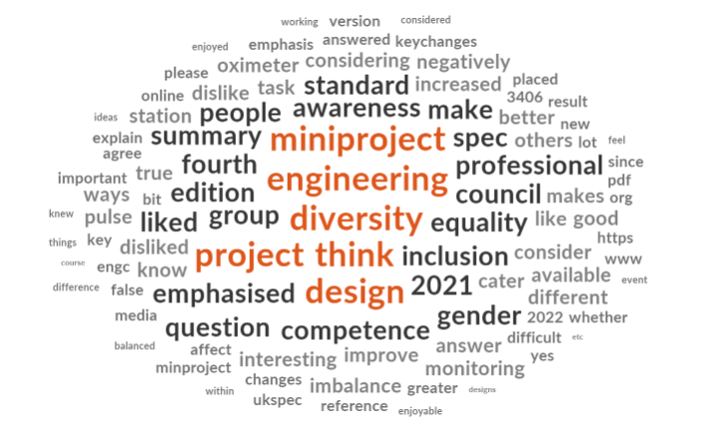
Figure 1: Word cloud of feedback from mini-project participants

The impact of the mini-project on group 1’s attitude to EDI included “I learnt to be more thoughtful for others” and “I can improve my own ways of making people feel included”. Perhaps of more relevance is how group 2 subsequently considered EDI in their own projects. Figure 2 compares how many times “diversity” and “equality” were mentioned in group 2’s own Project Initiation Documents (PIDs). It can be clearly seen that the SCQF level 9 Project students who completed the mini-project were more likely to consider engineering design for diversity and equality than those who did not.

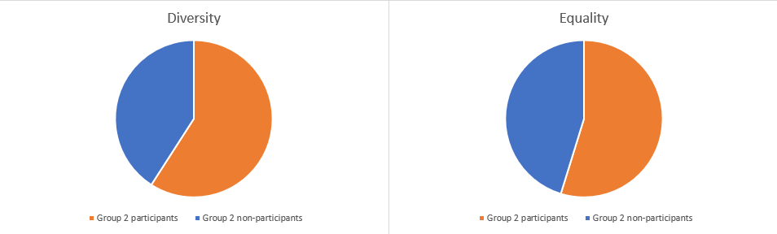
Figure 2: Comparison of frequency of words “diversity” and “equality”
in Group 2’s PIDs
With both groups there were few comments specifically about gender diversity, although two group 1 participants noted that “percentages of women in engineering are low and numbers must increase” and that “more gender balance in workplaces” is required. One student was uncomfortable with the gender focus of the group 1 activity, noting that “I did feel that the whole thing was more towards women and not a whole lot about men which is what the event was aimed at”.

Considering the differences between groups 1 and 2, the positive influence of the mini-project was more pronounced for SCQF level 9 participants than SCQF level 8 participants. Table 4 shows that 100% of level 9 participants noted a positive effect, compared to only 58.6% at SCQF level 8. Figure 3 illustrates the difference more visually. This is rather surprising given that the SCQF level 8 group were more diverse (Trolian and Parker 2022: 851) and had been taught about EDI more recently in their studies. However, academic study is not the only influence and it is likely that the SCQF level 9, more mature students, had deeper exposure through academic discourse and diversity in their workplaces. ChatGPT suggest that this “may develop a deeper understanding of the complexities and nuances of these concepts, making them more aware of systemic inequalities, social justice issues, and the importance of inclusivity in various domains, such as education, employment, and society as a whole” (OpenAI's ChatGPT AI language model, personal communication, 26th May 2023).

Table 4: Crosstabulation of SCQF Level versus Impact on EDI Consideration
 |  |  | Activity EDI Impact |  |  | Total
 |  |  | Negative impact on EDI consideration | Negligible impact on EDI consideration | Positive impact on EDI consideration
SCQF Level | SCQF level 8 | Count | 1 | 11 | 17 | 29
 |  | % within SCQF Level | 3.4% | 37.9% | 58.6% | 100.0%
 |  | % within Activity EDI Impact | 100.0% | 100.0% | 65.4% | 76.3%
 |  | % of Total | 2.6% | 28.9% | 44.7% | 76.3%
 | SCQF level 9 | Count | 0 | 0 | 9 | 9
 |  | % within SCQF Level | 0.0% | 0.0% | 100.0% | 100.0%
 |  | % within Activity EDI Impact | 0.0% | 0.0% | 34.6% | 23.7%
 |  | % of Total | 0.0% | 0.0% | 23.7% | 23.7%
Total |  | Count | 1 | 11 | 26 | 38
 |  | % within SCQF Level | 2.6% | 28.9% | 68.4% | 100.0%
 |  | % within Activity EDI Impact | 100.0% | 100.0% | 100.0% | 100.0%
 |  | % of Total | 2.6% | 28.9% | 68.4% | 100.0%

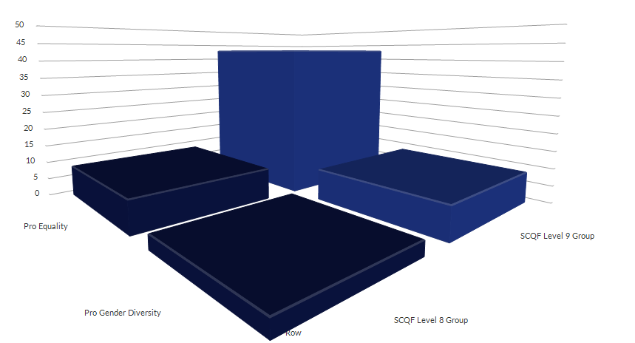
Figure 3: Comparing Groups 1 and 2’s views on Equality and Gender Diversity
post-workshops. Vertical scale is number of references in students’ feedback

Unfortunately, it was not possible to determine which responses were from females and which from males, so there is no correlation between the mini-projects and their effect on making engineering attractive for women. However, there were no negative comments made about the activities, and many participants noted that they enjoyed the mini-projects, particularly the ‘working with others’ aspects, with comments such as “I enjoyed that it was interactive and that there was a group task”, “working with more people as a team brings more ideas to the table”, “sharing a problem with many makes it easier”, and “it was encouraging to work together to realise strengths and weaknesses within a group atmosphere”. This suggests that group projects intrinsically promote diversity and are fun for students, even if not specifically focused on EDI.

Conclusions
The findings suggest that there is considerable benefit in running pro-social, collaborative projects, of the types described, with college learners. UHI North Highland engineering students, at SCQF levels 8 and 9, were found to enjoy the experience, which significantly raised their awareness of the importance of diversity, and, at level 9, impacted the students’ integration of EDI into their individual projects. The projects delivered social awareness metaskills (Skills Development Scotland 2018) and were a fun, and easy way, to build effective and inclusive practice into the curriculum (General Teaching Council for Scotland 2020: 6). Although the sample size was too small to imply generalisation, there was moderate correlation between participation and positive consideration of EDI. Unfortunately, although there was evidence that participants became more aware of the negative impact of lack of gender diversity in engineering, the hypothesis was not proved. There was no evidence that this awareness made the study of engineering more attractive to women, and in fact one student was uncomfortable with the gender focus.

To compound the results, it would be beneficial to continue the study with larger populations, perhaps including learners from other Higher Education Institutions (HEIs) and other subject areas. Although these mini-projects focussed on engineering, the solutions were not restricted nor judged on their practicality, thus the imparted skills of creativity, collaboration, problem solving, and presentation, are transferrable. Alternative projects could be specifically tailored to the cohort, for example ergonomic design of workplace tools (beauty, sports, equestrian, medical, etc. equipment).

References
Act of Parliament (2010) Great Britain Parliament. Equality Act 2010. London: HMSO

AdvanceHE (2021) National Teaching Fellows: Lois R. Gray [online]. Available from <https://www.advance-he.ac.uk/ntfs/lois-r-gray> [08/03/2023]

Beier, M., Kim, M., Sterbak, A., Leautaud, V., Bishnoi, S., and Gilberto, J. (2018) ‘The effect of authentic project-based learning on attitudes and career aspirations in STEM’ in Journal of Research in Science Teaching 56(1), 3-23

Bielefeldt, A., and Canney, N. (2015) ‘Gender Differences in the Social Responsibility Attitudes of Engineering Students and How They Change Over Time’ in Journal of Women and Minorities in Science and Engineering 21(3), 215-237

Botella, C., Rueda, S., López-Iñesta, E., and Marzal, P. (2019) ‘Gender Diversity in STEM Disciplines: A Multiple Factor Problem’ in Entropy 21(1), 30

Bryman, A. (2016) Social Research Methods 5th edn. London: Oxford University Press

Casad, B., Franks, J., Garasky, C., Killteman, M., Roesler, A., Hall, D., and Petzel, Z. (2020) ‘Gender inequality in academia: Problems and solutions for women faculty in STEM’ in Journal of Neuroscience Research 99(1), 13 - 23

Cohen, J. (1988) Statistical Power Analysis for the Behavioral Sciences. 2nd edn. Hillsdale, NJ: Lawrence Erlbaum Associates, Publishers.

Cornell, J., and Kessi, S. (2021) ‘Discrimination in Education’ in The Routledge International Handbook of Discrimination, Prejudice and Stereotyping. ed. by Tileaga, C., Augoustinos, M., and Durrheim, K. London: Routledge

Criado-Perez, C. (2020) Invisible Women: Exposing Data Bias in a World Designed for Men. London: Vintage Publishing

Direito, I, Chance, S., Clemmensen, L., Craps, S., Economides, S., Isaac, S., Jolly, AM., Truscott, F., and Wint, N. (2021). Diversity, Equity, and Inclusion in Engineering Education: an Exploration of European Higher Education Institutions' Strategic Frameworks, Resources. ‘49th Annual Conference of the European Society for Engineering Education (SEFI 2021)’. Held September 13-16 2021 at Berlin

Dyack, A. (2020) ‘Situated Learning Theory’ in E Learning Essentials. ed. by Power R. [online]. Available from <https://pressbooks.pub/elearning2020/> [21/03/2023]

Edutopia (2023) Project Based Learning (PBL) [online]. Available from <https://www.edutopia.org/project-based-learning> [20/03/2023]

Engineering Council (2020) Accreditation of Higher Education Programmes (AHEP) 4th edn. London: Engineering Council

--. (2020) The UK Standard for Professional Engineering Competence and Commitment (UK-SPEC) 4th edn. London: Engineering Council

Engineering UK (2020) Educational pathways into engineering. London: EngineeringUK

--. (2022) Women in engineering. London: EngineeringUK

Equality and Human Rights Commission (2011) Public Sector Equality Duty [online]. Available from <https://www.equalityhumanrights.com/en/advice-and-guidance/public-sector-equality-duty> [14/03/2023]

Fan, H., Xie, H., Feng, Q., Bonnizoni, E., Heidari, H., McEwan, M., and Ghannam, R. (2023) ‘Interdisciplinary Project-Based Learning: Experiences and Reflections From Teaching Electronic Engineering in China’ in IEEE Transactions on Education 66(1), 73-82

Davis, K. (2019) ‘20 Facts And Figures To Know When Marketing To Women’ in Forbes [online]. Available from <https://www.forbes.com/sites/forbescontentmarketing/2019/05/13/20-facts-and-figures-to-know-when-marketing-to-women/> [22/03/2023]

General Teaching Council for Scotland (2020) Professional Standards for Lecturers in
Scotland’s Colleges. Edinburgh: GTC

Gomez, J., Tayebi, A., and Delgado, C. (2022) ‘Factors That Influence Career Choice in Engineering Students in Spain: A Gender Perspective’ in IEEE Transactions on Education 65(1), 81 - 92

Gray, L. (2021) ‘Attracting women into engineering – a personal reflection’ in A book in celebration of International Women's Day 2021. ed. by Walker, A. Inverness: UHI, 236 - 239

--. (2022) ‘Case Study 2.7 - Group Activity 1: Pulsimeter Mini-Project’ in Handbook for Creating a Gender- Sensitive Curriculum: Teaching and Learning Strategies. ed. by Kitchener, M. Oxford: Oxford-Brookes University

Hadgraft, R, and Kolmos, A. (2019) ‘Emerging learning environments in engineering education’ in Australasian Journal of Engineering Education 25(1), 3 - 16

Holmes, V-L., and Hwang, Y. (2016) ‘Exploring the effects of project-based learning in secondary mathematics education’ in The Journal of Educational Research 109(5), 449 - 463

Kricorian, K., Seu, M., Lopez, D., Ureta, E., and Equils, O. (2020) ‘Factors influencing participation of underrepresented students in STEM fields: matched mentors and mindsets’ in International Journal of STEM Education 7(16), 1 - 9

Larson, J., Jordan, S., Lande, M., and Weiner, S. (2020) ‘Supporting Self-Directed Learning in a Project-Based Embedded Systems Design Course’ in IEEE Transactions on Education 63(2), 88 - 97

Mertens, D. (2014) Research and Evaluation in Education and Psychology: Integrating Diversity With Quantitative, Qualitative, and Mixed Methods [online]. Available from <https://www.sagepub.com/sites/default/files/upm-binaries/29985_Chapter1.pdf> [05/01/2023]

McKinsey & Company (2020) Diversity wins: How inclusion matters [online]. Available from <https://www.mckinsey.com/featured-insights/diversity-and-inclusion/diversity-wins-how-inclusion-matters> [26/05/2023]

OpenAI, ChatGPT to Lois Gray, Output,26th May 2023. Note: Output from ChatGPT, Open AI to Lois Gray, [26/05/2023].

Parks, M. (2023) The History of Arduino Part 1: Introducing Arduino [online]. Available from <https://www.mouser.com/blog/history-arduino-part-1> [24/03/2023]

Romero, J., Jimeno-Morenilla, A., Pertegal-Felices, M., and Mora-Mora, H. (2019) ‘Design and Application of Project-Based Learning Methodologies for Small Groups Within Computer Fundamentals Subjects’ in IEEE Access vol. 7, 12456-12466

Royal Academy of Engineering (2014) University Technical Colleges: Opening up new opportunities for girls. London: Royal Academy of Engineering

--. (2020) Closing the engineering gender pay gap. London: Royal Academy of Engineering

Shekar, A. (2012) ‘Research-based enquiry in Product Development education: Lessons from supervising undergraduate final year projects’ in International Journal of Industrial Engineering 19(1)

Skills Development Scotland (2018) Skills 4.0: A skills model to drive Scotland’s future [online]. Available from <https://www.skillsdevelopmentscotland.co.uk/media/44684/skills-40_a-skills-model.pdf> [13/06/2023]

Smith, D., Rosenstein, J., and Nicolov, M. (2018) ‘The Different Words We Use to Describe Male and Female Leaders Harvard Business Review’ [online]. Available from <https://hbr.org/2018/05/the-different-words-we-use-to-describe-male-and-female-leaders> [24/03/2023]
Stentiford, L. (2018) ‘You can tell which ones are the laddy lads’: young women’s accounts of the engineering classroom at a high-performing English university [online]. Available from <https://www.tandfonline.com/doi/full/10.1080/09589236.2018.1423957> [16/01/2023]

Soutschek, A., Burke,C., Raja Beharelle, A., Schreiber, R., Weber,S., Karipidis, I., ten Velden, J., Weber, B., Haker, H., Kalenscher, T.and Tobler, P. (2017) ‘The dopaminergic reward system underpins gender differences in social preferences’ in Nature Human Behaviour 1(11), 819-827.

Trolian, T., and Parker, E. (2022) ‘Shaping Students’ Attitudes Toward Diversity: Do Faculty Practices and Interactions with Students Matter?’ in Research in Higher Education 63:849–870

UHI (2021) Zooming in on Graduate Attributes. Inverness: UHI

--. (2023) Learning and Teaching Enhancement Strategy. Inverness: UHI

UNESCO (2017) Sustainable Development Goals [online]. Available from <https://en.unesco.org/sustainabledevelopmentgoals> [24/03/2023]

Van den Beemt, A., MacLeod, M., Van der Veen, J., Van de Ven, A., Van Baalen, S., Klaassen, R., and Boon, M. (2020) ‘Interdisciplinary Engineering Education: A Review of Vision, Teaching, and Support’ in The Research Journal for Engineering Education 109(3), 508-555

Vu Tran, H. (2019) ‘Diversity’s twilight Zone: how affirmative action in education equals ‘discrimination’ in the colorblind era’ in Race Ethnicity and Education 22(6), 821-835

Wajngurt, C., and Sloan, P. (2019) ‘Overcoming Gender Bias in STEM: The Effect of Adding the Arts (STEAM)’ in Insight: A Journal of Scholarly Teaching 14, 13-28

Appendices

Appendix 1
Design 4 Diversity Workshop

The Problem:
Conventional, single wheel, wheelbarrows are awkward for many people to use – tall people or people with long legs, disabled or weak people, people with short arms or narrow shoulders, people who tire easily, and people who have difficulty with hand-eye co-ordination or balance.

Tasks:
You have 1 hour, working within your team, to redesign or modify the design of the conventional, single wheel, wheelbarrow, so that it is easier for a more diverse range of people to use. Then 10 minutes for your team to present their design to the other workshop participants and answer questions.

Constraints:
- No electrical power sources are allowed (i.e. no batteries, mains power, robots, etc.).
- Fantastical designs are not allowed (i.e. no flying wheelbarrows, wheelbarrows propelled by animals, etc.).

Team Roles:
The first thing you should do is allocate people in your team for the following roles. If you are unable to agree roles, tell us and we will assign them for you.

Team Leader
- Ensures the team stays on task.
- Ensures the team works well together.
- Resolves any disagreements.
- Has the final say in all decisions.
This would suit someone who is good at motivating others, listening to ideas, and making diplomatic but firm decisions.

Project Planner
- Defines sub-tasks with timescales for each sub-task.
- Times each sub-task and ensures they don’t overrun.
- Ensures the team finishes the full redesign or modification on time.
This would suit someone who is well ordered, likes to be punctual and likes to get things finished.

Draughtsperson
- Tidily sketches or writes details of any sub-task designs or ideas.
- Draws the final design for presentation.
This would suit someone who has neat writing, likes drawing, and can easily understand descriptions.
Marketing Co-ordinator
Everyone in the team should contribute to presenting the design and explaining, in the presentation, why the new wheelbarrow is better for a more diverse range of people. However, a single marketing co-ordinator should
- Lead the presentation of the final design.
- Answer questions about the final design.
This would suit someone who speaks clearly and is not too shy to stand up in front of people.

Designers
Everyone in the team should contribute to the design, but any team member who is not allocated another role will be a designer.
- Researches existing designs.
- Comes up with improvement ideas and discusses these with other team members.
- Collaborates with other team members to hone and optimise their ideas.
A good team will have designers with different capabilities and interests – creative people, people who like researching, people who like working with others, people who like working alone, people who like brainstorming, people who are knowledgeable, problem solvers, and many others.

Appendix 2
Redesign or improvement of pulse oximeter monitoring station in hospitals.
Problems:
Fingertip Pulse Oximeters can be uncomfortable or inaccurate. For example thickness or shape of finger, nail or skin colour, pulse strength, and skin temperature can all adversely affect readings .
Monitoring stations can be uncomfortable for tall or short people to work at, or might not suit people with disabilities (e.g. unclear displays, difficult to reach controls, restricted access, heavy equipment, etc.).
Aims:
To raise awareness of non-technical project considerations.
For fun – teamworking and getting to know your peers.
For my action research into equality, diversity, and inclusion.
Tasks:
- Assign roles:
Team Leader – ensures team stays on task and time, and has final say in decisions
Designers – comes up with ideas and justifies them
Presenter/Researcher – checks ideas are viable and presents them in class
Improve the pulse oximeter and monitoring station design, with particular emphasis on human factors and design for equality, diversity, and inclusion.
3. Present your team’s improvements (next week).
4. Individually answer a questionnaire and take part in a discussion about equality, diversity and inclusion awareness.
RESEARCH RESULTS PUBLISHED WILL BE COMPLETELY ANONYMOUS

Appendix 3
Feedback Form
What did you enjoy about the Equality Event today?
What did you learn?
Is there anything you would change about today’s event?

Appendix 4

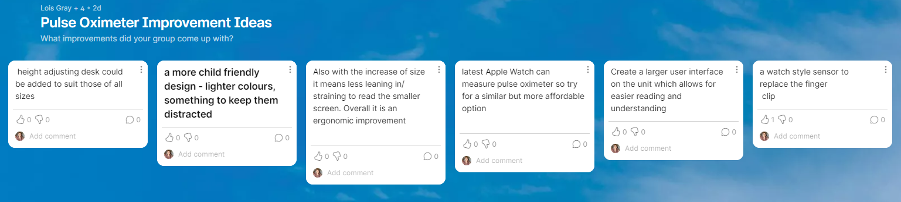

Appendix 5

Question 1
In the new UK Standard of Professional Engineering Competence (UK SPEC) version 4, the Engineering Council has placed "greater emphasis on diversity and inclusion" (2021: 4). Did you know this and do you agree that this should be emphasised?
Reference:
Engineering Council (2021) UK Standard of Professional Engineering Competence (UK-SPEC) fourth edition: summary of key changes [Online]. Available from https://www.engc.org.uk/media/3406/uk-spec-fourth-edition-summary-of-key-changes.pdf [12/09/2022]

I knew this and I think it should be emphasised
I knew this but I don't think it should be emphasised
I didn't know this, but I think it should be emphasised
I didn't know this and I don't think it should be emphasised

Question 2
Did you like or dislike the mini-project to improve a Pulse Oximeter and Monitoring Station, to better cater for diversity?

I liked it a lot
I liked it a bit
No opinion
I disliked it a bit
I really disliked it

Question 3
Please explain your answer to question 2 (whether you liked or disliked the mini-project).

Question 4
Since doing the mini-project, do you have an increased awareness of design for diversity, and why it is important?

My awareness has increased a lot
My awareness had increased a little
There is no difference in my awareness
My awareness has decreased

Question 5
Do you think this is true or false: "Gender imbalance negatively impacts engineering"?

True
False

Question 6
If you answered "True" to question 5, in what ways does gender imbalance negatively affect engineering?

Question 7
As a result of doing the mini-project, will you consider design for equality, diversity, and inclusion in your own project?

Yes, to a great extent
Yes, to a slight extent
No difference
I will consider it even less

Question 8
Do you think that considering design for diversity makes a project more interesting?

Yes, and it doesn't make it more difficult
Yes, but it does make it more difficult
No, although it doesn't make it more difficult
No, and it does make it more difficult
No opinion

